**Lighthouse Audit Summary for Comforty**

* **Audit Date**: [Insert Date]
* **Lighthouse Score**: **99%**

**Key Findings:**

* **Performance**: 98%
  + **Issue**: Minor unused JavaScript and large images.
  + **Solution**: Optimize images (WebP, Next.js Image Optimization), apply code splitting, and preload critical assets.
* **Best Practices**: 99%
  + **Issue**: Mixed Content (HTTP/HTTPS warnings).
  + **Solution**: Ensure all resources are served over HTTPS.
* **Accessibility**: 100%
  + **No issues** found. Site is fully accessible.

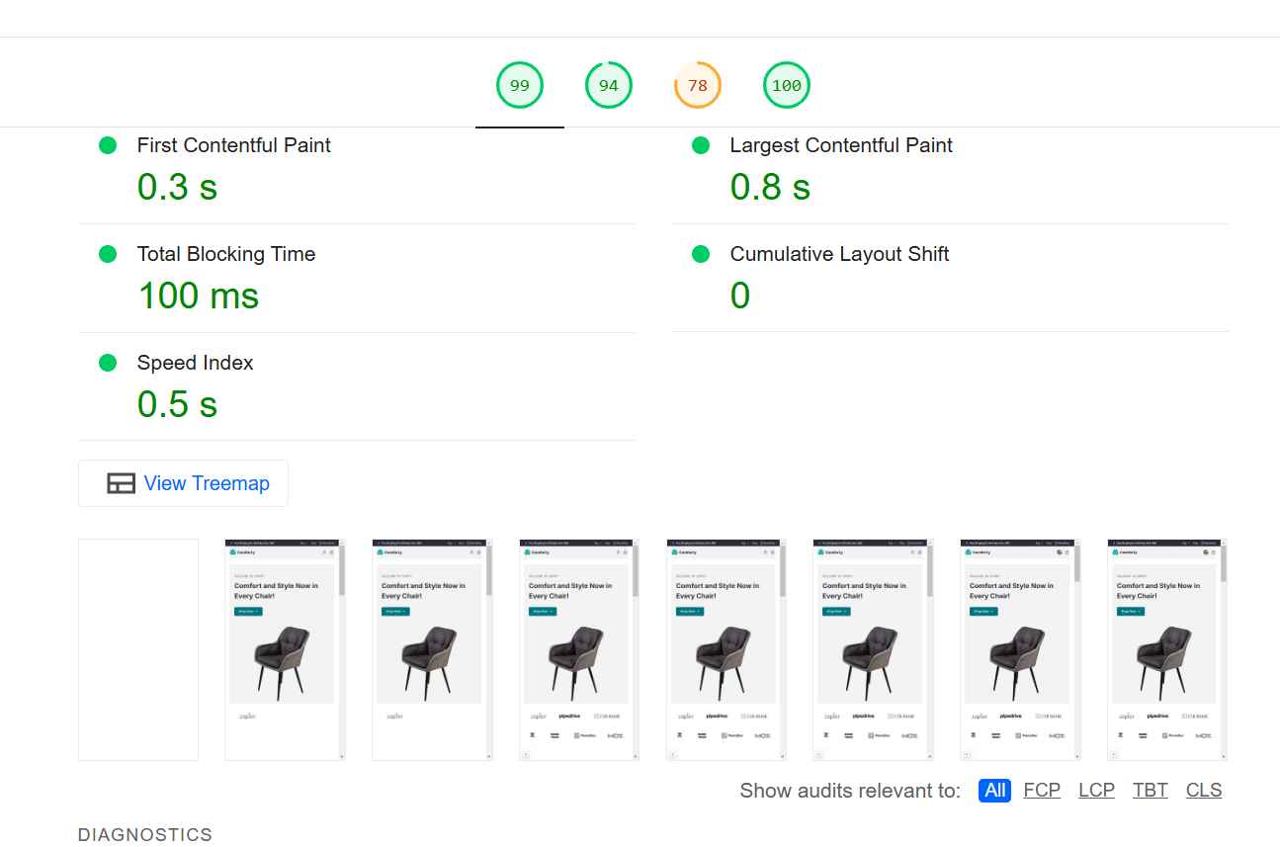

* **SEO**: 100%
  + **No issues** found. SEO is well-optimized.



